|  |  |
| --- | --- |
|  |  |
| Project Name: Allowance program Management system |  |
|  |  |
|  | COURSE TITLE Database Management System |
|  | STUDENT’S NAME Md Kawser Ahmad 1722103042  Md.Jahid Hasan 1922108042 TEACHER’S NAME Ahmed Fahmin  Nazmul Alam Dipto |

**Introduction:**

Bangladesh is a densely populated country. A significant share of people is affected by disabilities and Widow’s women in Bangladesh represent about a tenth of ever married women in the country. However, elderly people in Bangladesh also struggle to maintain a dependable income since finding employment is harder with age. Despite economic progress in Bangladesh, due to social stigma and patriarchal social norms, widows, disable people and elderly people tend to be highly vulnerable to poverty. Allowances for the financially insolvent disable, widowed or elderly people aim to provide poor disable, widowed women and old people with cash transfers to improve their socio-economic wellbeing. However, this web application we will made contain all information of allowances for disable, widow women and elderly people. They can log into the web application and see the amount of their allowance. It will also notify them (disable, elderly people and widow women) about their allowances and the date they can withdraw their allowance money.

About Allowance program Management system:

An Allowance program Management system is a web-based system solution which helps authority to manage allowance according to their needs. The Allowance program Management system solution provides easy and hassle-free solution for everyday task for allowance program authority. This system creates a technology enable environment; where individuals, system, authority & people will be able to interact with each other for better services and other administration process.  
  
An Allowance program Management system may also provide allowance program authority with the ability to use interactive features such as threaded discussions, allowance request accept and decline etc. Besides, it facilitates administration, documentation, tracking and reporting of allowance program.

Repository link:https://github.com/Gigawashu/Allowance_Program

**Purpose:**

* To easily sign up for allowances.
* Announcement of allowances.
* To easily distribute.
* To collect Information.
* To Estimate the budget.
* To Analyze allowance information

**Benefits Of Allowance Program Management system:**

**Ability to deliver engaging and motivating training**

This is a fact that each individual learns in a unique manner. If you apply different learning approaches, they increase your success rate. Allowance Program management system help in communication and balance the  
whole system.

**Technology leverage**

In this digital world the working system has totally changed. Today every employee is engaged with a laptop or desktop, and with the help of Allowance Program management system you can make the training future ready, it becomes interesting and exciting for your target audience.

**Tracking and reporting features**

Another benefit of using an Allowance Program management system is that you can enhance performance through tracking and reporting tools. New users’ progress can be tracked, records can be reviewed, and users  
can register for more than one allowance. Management can access the records and calculate which area needs improvement. The people who benefited by allowance also become aware of the areas that need  
improvement and additional efforts, as the weak performance areas, can be identified easily.

**Evaluation capabilities**

Users can evaluate about their allowance, and authorities can keep a track of users and real time performance by periodically scheduling assignment.

**Easy upgrades**

Content and information can be easily upgraded, as Allowance Program management system offer a centralized location for information which makes it simple to implement changes; plus, all users get the same upgraded information at the same time.

**Interactive environment.**Through new online tools, the interaction and communication part improved. Allowance beneficiaries get their answers in real time about their allowance and the engagement is more geared toward being interactive.

**Allowance System Management System Features:**

Finally, some common features found in the majority of Learning  
Management Systems include:

**1. Managing users, allowances, and generating reports**

With this helps admin can generate various reports manage users.  
.

**2. Messaging and notifications**Admin can send reminders and notifications about the allowances a beneficiary can get.

**3. Assessments that can handle pre/post testing.**

**4. Allowance request accept decline**

Admin can accept or decline the allowance request of people.

**5. Administration**

**6.** **Access history**

Admin can check the allowances a beneficiary gets over a certain period of time.

**7. Competency management.**

With the help of this feature admin or authority can track and check the allowances  
a beneficiary will get.

**User Story**

Mr. ABC, the allowance seeker needs desperate allowance. He has two options.

**Use Case:**

a) Search in the site for their interest allowance.  
b) Request for allowance by submitting necessary documents.

c) Wait for authority approval to get into specific allowance program.

d) Get id and Login in the system for getting allowance.

**Limitations of the Allowance Management System**  
• IT Culture. Centralize and control approach to this field technology.  
• Limited informal learning possibilities.  
• Allowance based model that **limits** community development.

**Front-end plan**

There are some templates in plan  
1. Admin login page  
2. User Login page  
3. Register page  
4. Allowance details page  
5. User details page  
6. Notice Board  
7. User Profile page  
8. Allowance Status Page

9. Logout page

**Back-end development**

1. Account Creating:  
a. Sign up form, verification by Nid.  
b. Login

2. Profile Management:  
a. User Profile  
b. Allowance Profile  
c. Others

**Tools and Technologies:**  
1. Database: MySQL  
2. Protocol: Http  
3. SMS API: https://bulksmsbd.com/  
4. Cloud Provider: AWS  
5. PHP

**Advantages:**

There are six major advantages of Allowance Program management system:  
interoperability, accessibility, reusability, durability, maintenance ability and adaptability, which in themselves constitute the concept of Allowance Program management system.

**Definition, Acronyms & Abbreviation:**

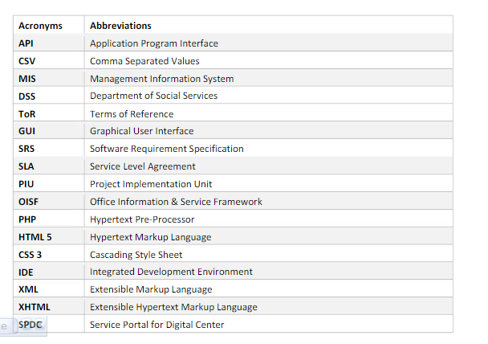

**Hardware/Hosting Plan:**

Here is a list of possible cloud plans. We have to choose one that fits best and also economical

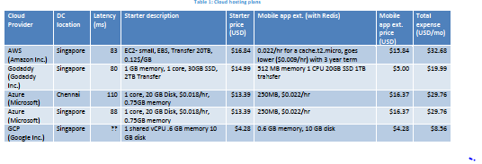

**Project Schedule:**

Phase 1 will take a total of 6 weeks from the day of start. Calculated Man-month = 8.5/4 = 2.123. Excluding front end development, it will become

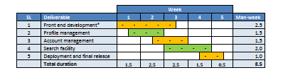

**Budgetary Price:**

Excluding front end development (2.5 man-week) total time plan = 6 weeks. Following table shows LMS expense. In addition, based on requirement as it  
reveals during project NSU LMS will help one choose the appropriate cloud hosting. That expense is not included here.

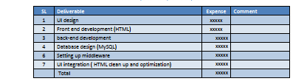

**Some Screenshots of Project:**

**Admin:**

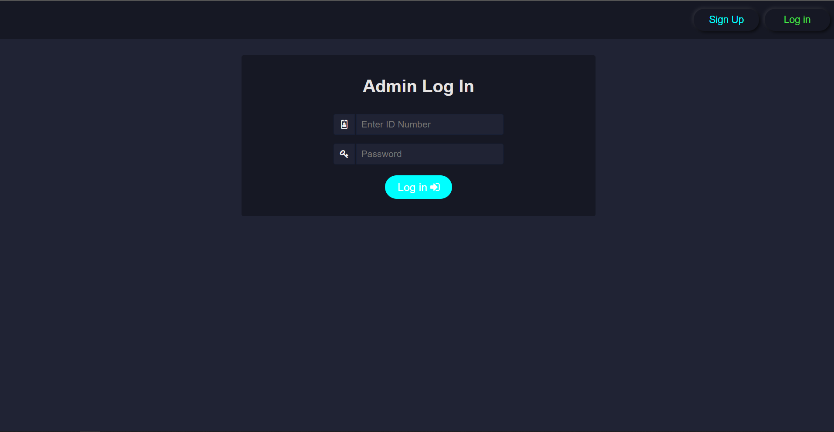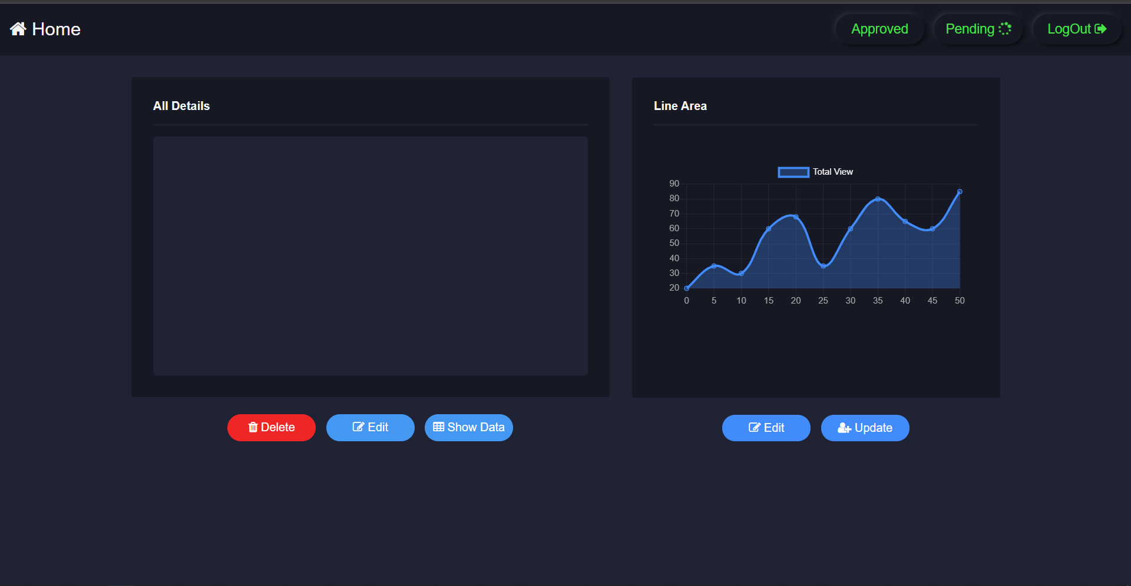

**Pending Requests:**

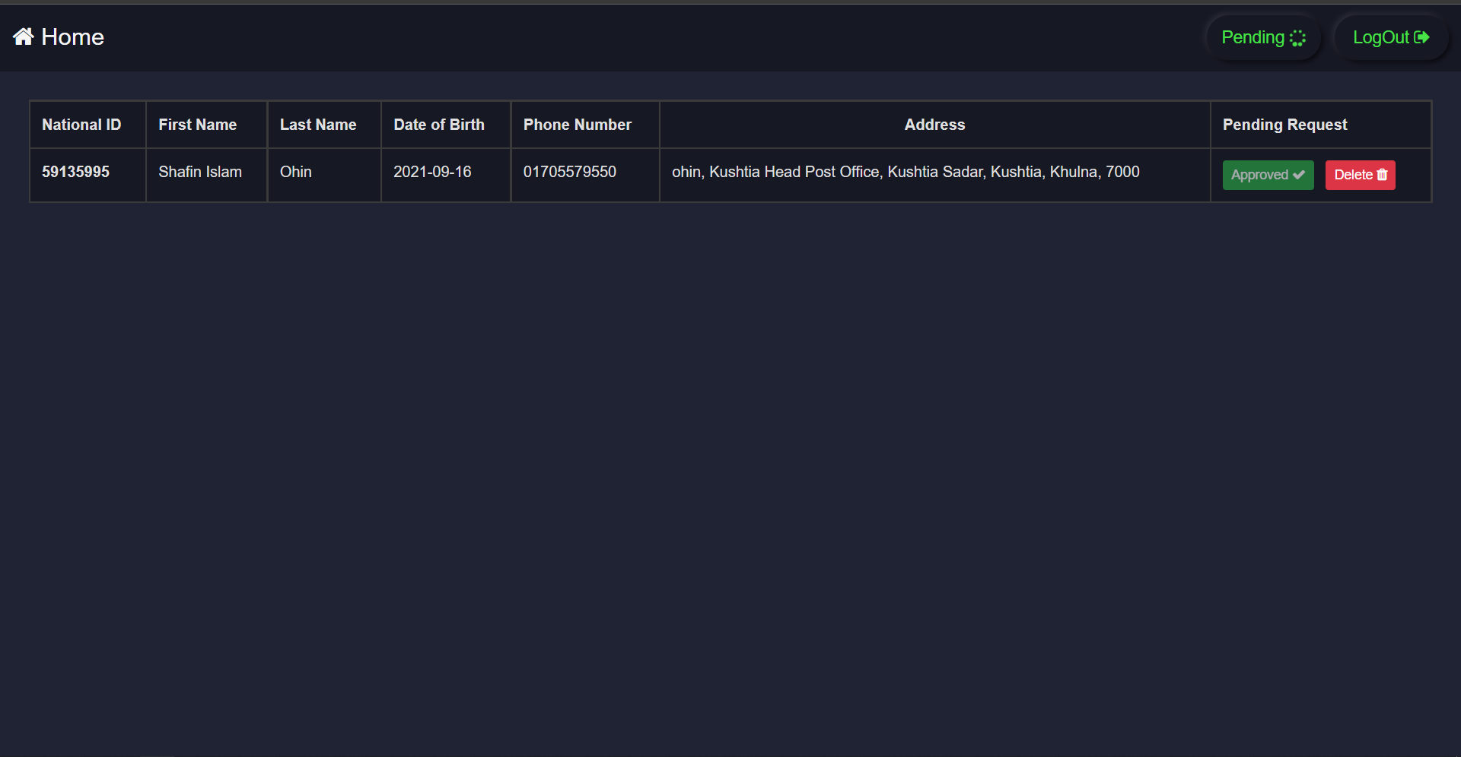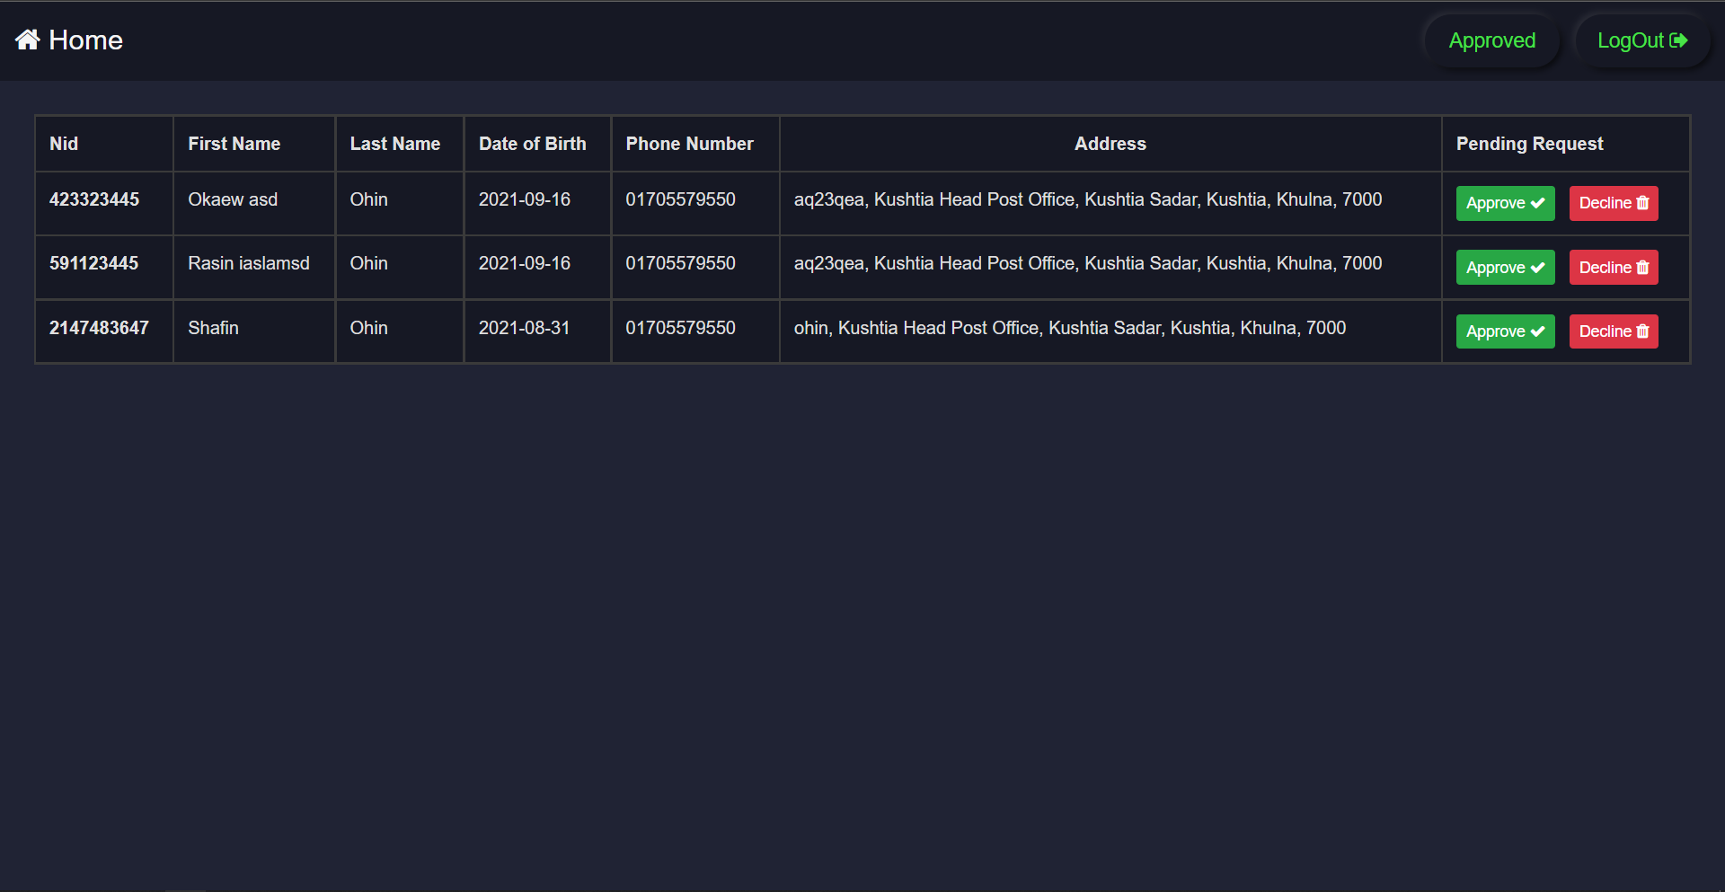

**Announcements:**

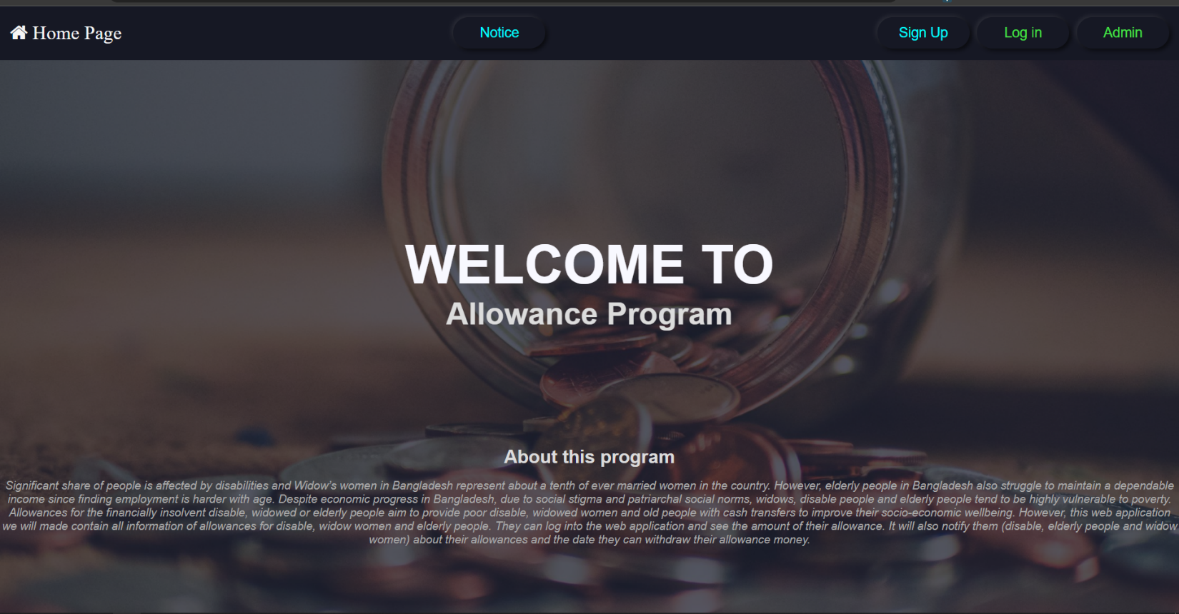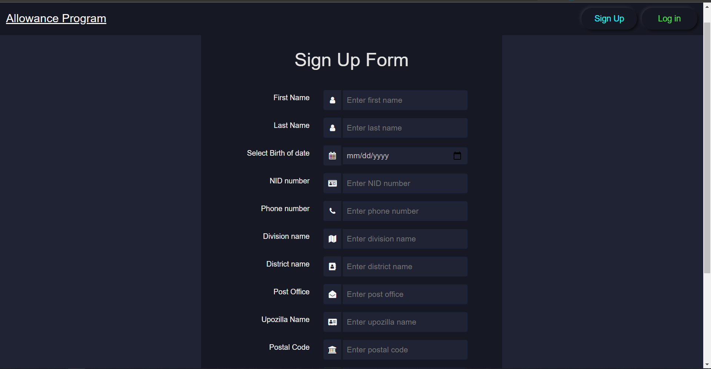

**User Login:**

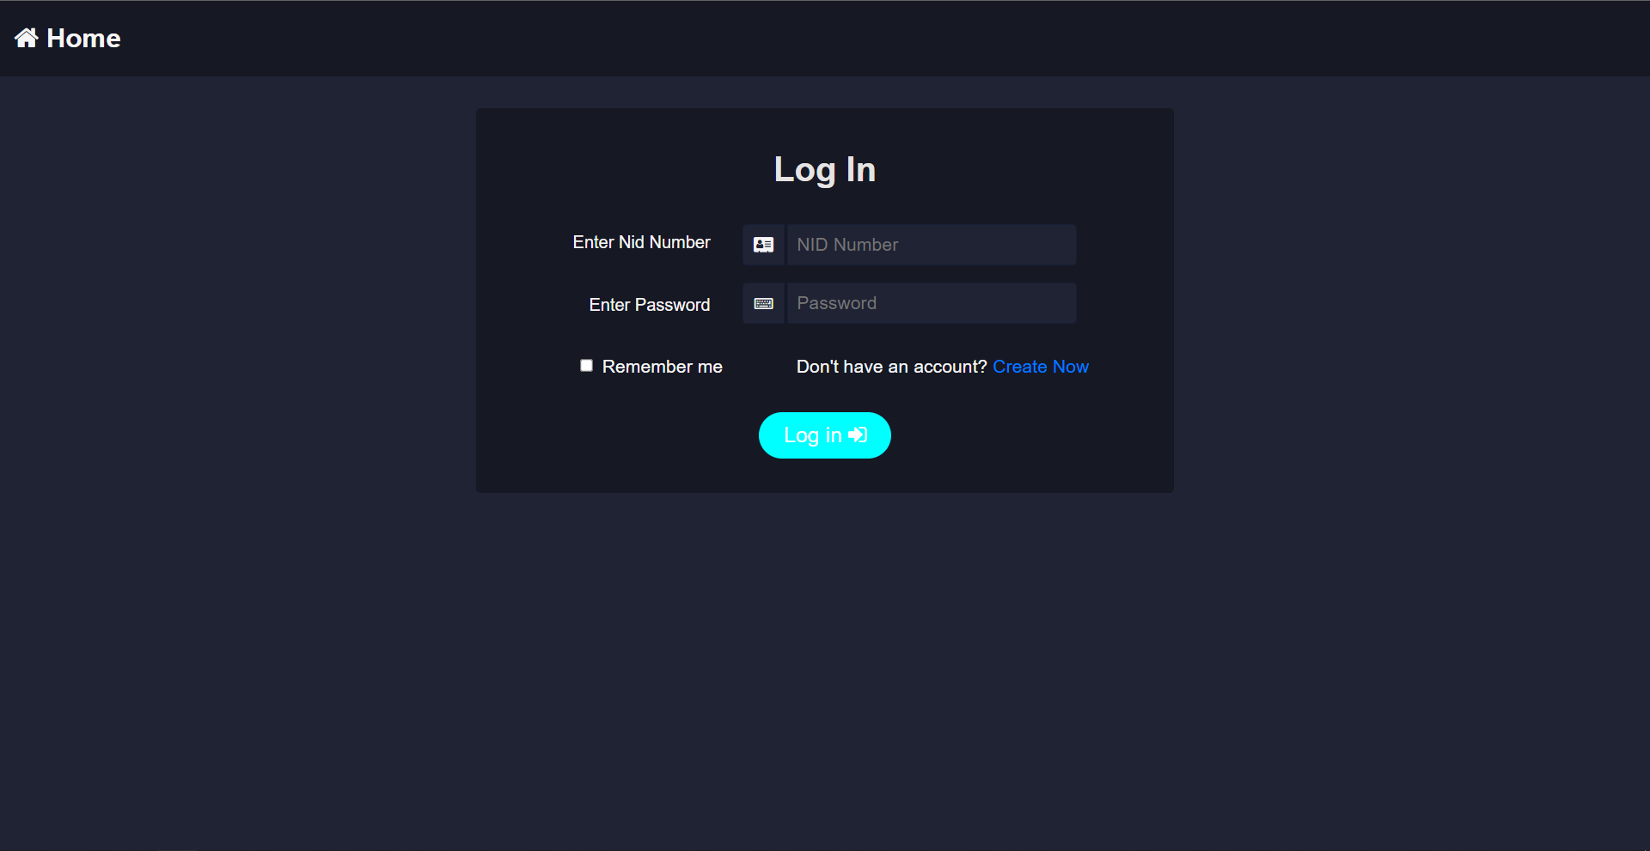

**Conclusion:**  
  
❑ An Allowance Management System is a technological tool used to  
manage allowance and its beneficiary.  
❑ An Allowance Management System may also provide additional advanced features including  
the ability to manage payments and users.

**Appendix**

**Contact information**

**Md Kawser Ahmad**

[**Kawser.ahmad@northsouth.edu**](mailto:Kawser.ahmad@northsouth.edu)

**Md.Jahid Hasan**

[**jahid.hasan19@northsouth.edu**](mailto:jahid.hasan19@northsouth.edu)